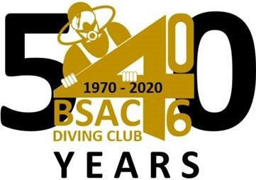

Welcome to BSAC 406 weekly Dive Log. Please contact Ian Hussey if you would like to contribute to the weekly newsletter that is distributed to BSAC 406 members worldwide.
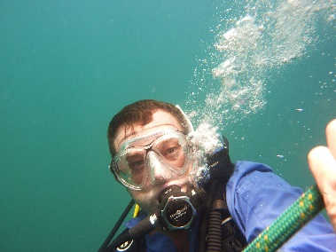

The “Old Faithful” Land Rover Discovery has been on its last legs for a while, and when confronted by a lengthy list of repairs necessary to get it through its latest registration, we realized the end had come. It was not without sadness. The car has been towing the boats for a number of years now and it was previously owned by Mike Anthony and before that, Doug Fontaine so it has some history with us. Our new vehicle is a Land Cruiser Prado, 1999 model but in good condition for which we paid Dhs 20,000.

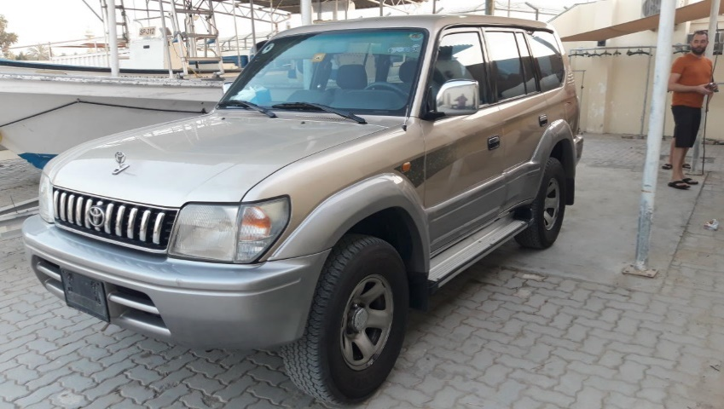
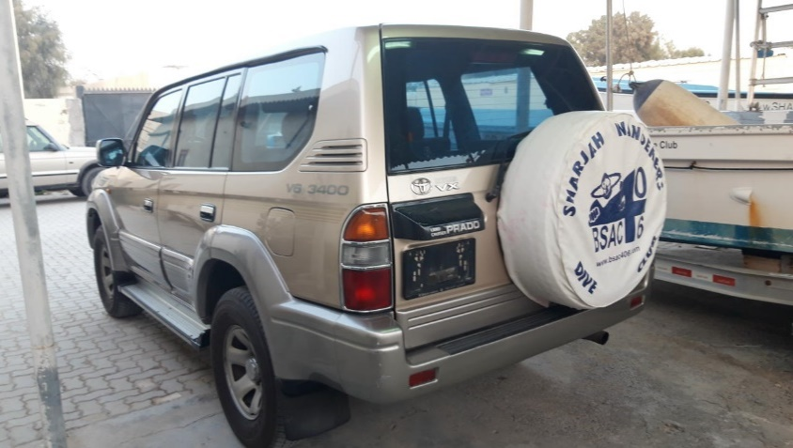
We now just need a tow-hook fitted which is in hand. The car did however get a maiden journey down to Al Khan slip on Friday carrying some tanks.
-----------------------------------
We were out on the water on Friday with a trip to the Jumbo and Neptune. The sea state was flat calm, the current was minimal and the viz was on the reasonable side. After a couple of passes over the Jumbo we finally got the anchor in near the prop and could go exploring. There were a few Barracuda and some Batfish but mainly what was memorable were the Rays. Having had a quick glimpse of a stingray, a few metres away from the wreck but approaching the bow, we saw other divers stationary and taking some video. Getting closer there was a large Cow-Tailed Ray gliding on top of the wreck. After a couple of minutes it swam away but it was a memorable encounter. At the end of the dive we saw an Electric Ray resting in the sand a couple of metres away from the anchor.
Dive two on the Neptune was similar. This time we didn’t see any Rays but other divers did and brought back photographic evidence to prove it.
A good day all round. The water is showing signs of warming up slightly but it would be a brave diver who dispensed with the wet suits just yet. The sea state had picked up by the time we returned home – it was at least 0.1m. Below are a couple of stills. The Cow-Tail isn’t very clear unfortunately but you might get some idea.
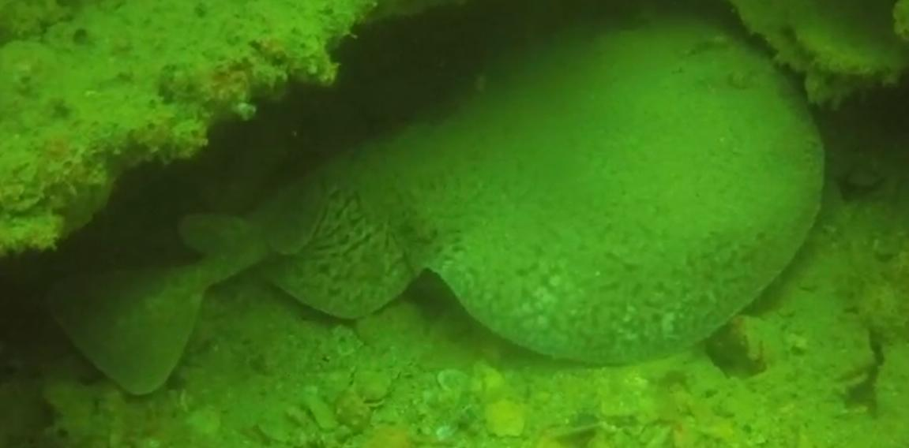
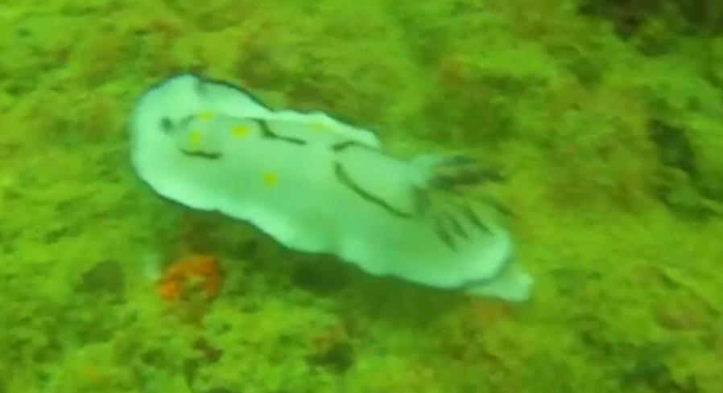
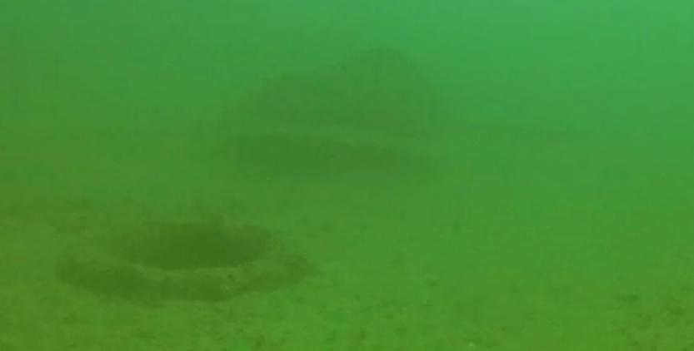

We were tempted to fine diver of the day for the grievous crime of coming on the boat wearing socks but that seemed a bit harsh given that it was his first dive with us. A moratorium on fines was thus declared for the day.
As of Tuesday, the Discovery is sold to an Emarati car collector who intends to refurbish the car. He promised to send us photos when done – I hope he does a nice job.
Come the end of the month, come the next Zoom call. If you want to participate please contact Robin or Ian for login details.

Joining BSAC:
New members to BSAC can join Sharjah Wanderers Diving Club via the website, https://www.bsac.com/membership/select-branch/ . If you enter Sharjah, the club appears. Existing BSAC members can renew by logging into MyBSAC or using this link, https://www.bsac.com/membership/rejoin-today/
BSAC general website: https://www.bsac.com/home/
DAN insurance website: https://www.daneurope.org/home

The Dive Club meets every Tuesday night in the Dive Bar.
See you there.
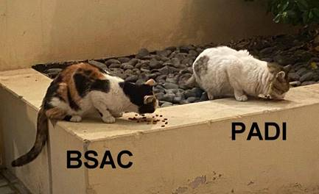

IMAGE COPYRIGHT / REFERENCES:
Polly Buckingham
Ian Hussey
Cara Black
Allen Doyle

