

Welcome to BSAC 406 weekly Dive Log. Please contact Ian Hussey if you would like to contribute to the weekly newsletter that is distributed to BSAC 406 members worldwide.
This week the Jackson family sent through some beautiful pictures. The wreck is one of interest.



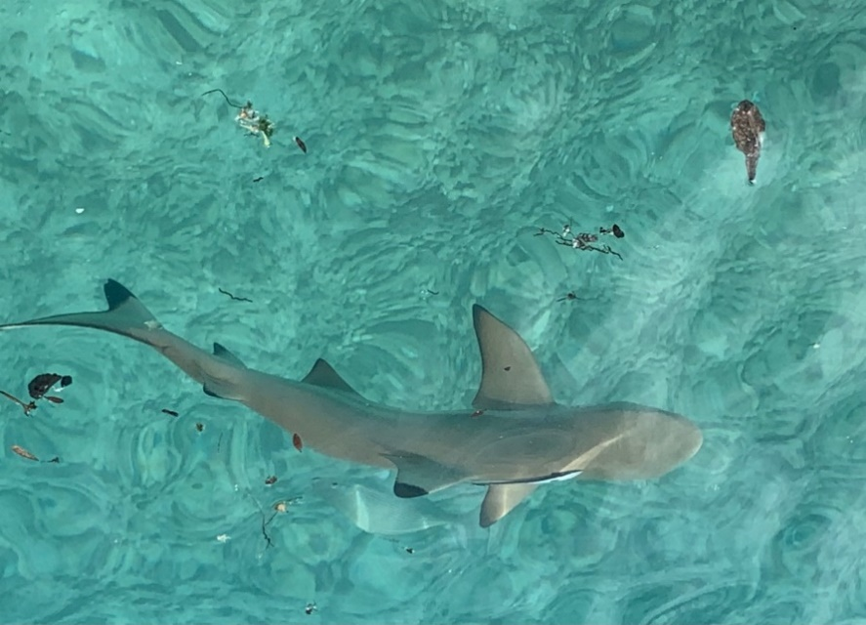
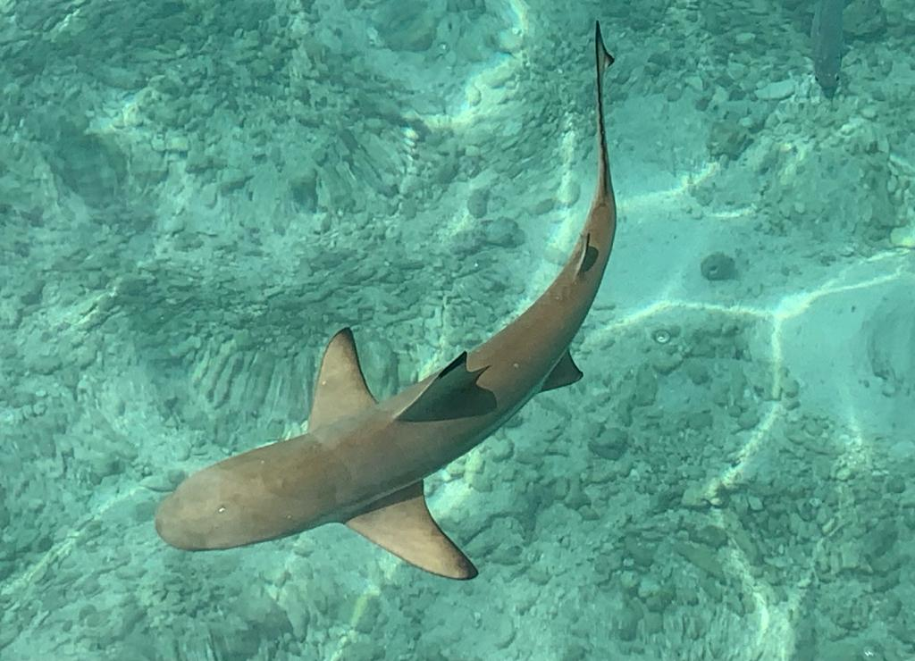


Joining BSAC:
New members to BSAC can join Sharjah Wanderers Diving Club via the website, https://www.bsac.com/membership/select-branch/ . If you enter Sharjah, the club appears. Existing BSAC members can renew by logging into MyBSAC or using this link, https://www.bsac.com/membership/rejoin-today/
BSAC general website: https://www.bsac.com/home/
DAN insurance website: https://www.daneurope.org/home

The Dive Club meets every Tuesday night in the Dive Bar.
See you there.
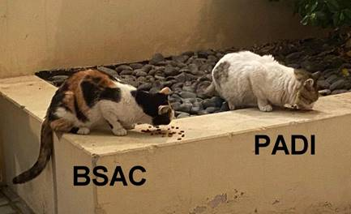

IMAGE COPYRIGHT / REFERENCES:
Polly Buckingham
Ian Hussey
Peter Jackson

